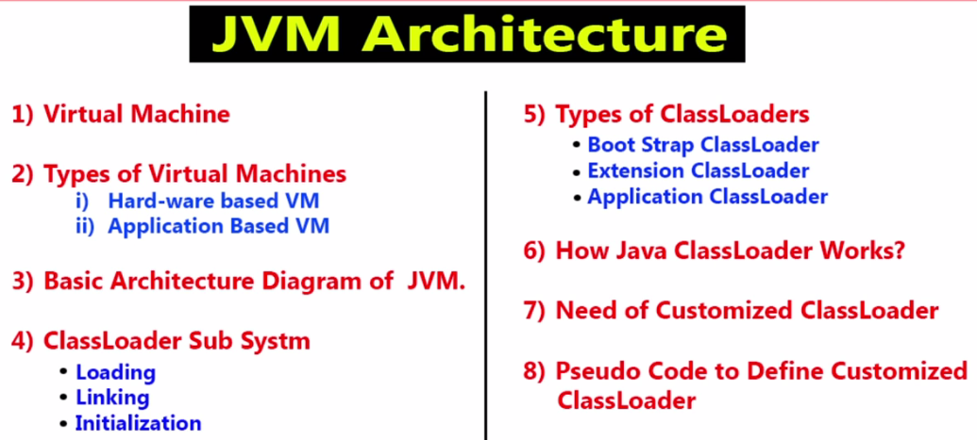

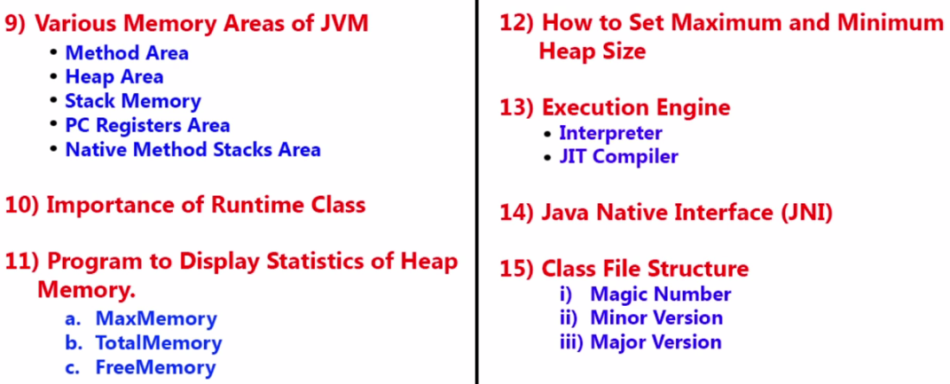

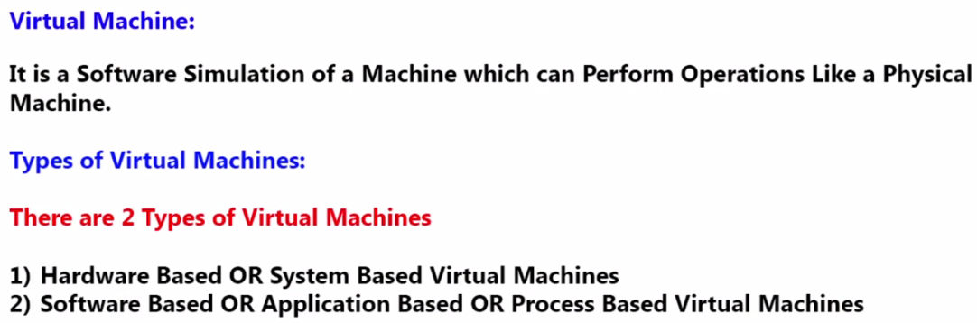

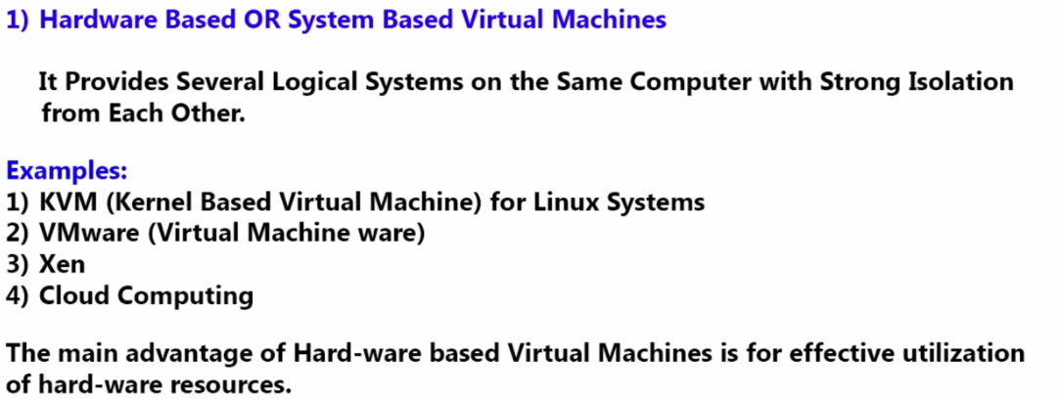

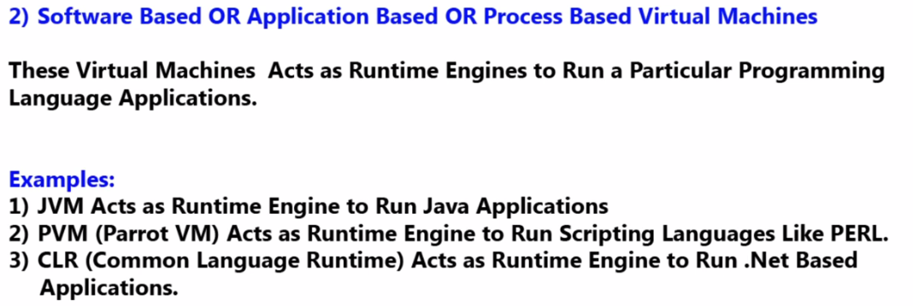

**Virtual**: Not having physical existence.

**Virtual Machine:**

A software simulation of a machine which can perform operations like a physical machine.

It does not have any physical existence.

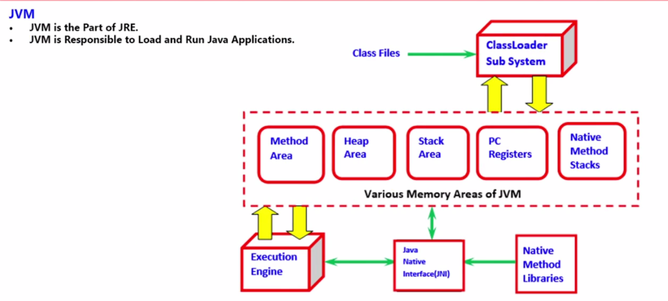

JVM is part of JRE.

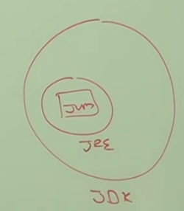

JVM is used to load and run the class file.

3 important components of JVM:

1. Class Loader Sub System:

It is used to load the class file in some memory area (Method Area). Execution engine is used to run the class file line by line.

1. Memory Area:
2. **Method Area:** .class file will be saved
3. **Heap Area:** objects will be saved
4. **Stack Area:**
5. **PC Register**: Current executing instruction address can be given by PC Register.
6. Native method stacks:
7. Execution Engine: Run the class file line by line.
8. Java Native Interface (JNI): It provides information about the native method libraries to Execution engine.
9. Native Method Libraries: The methods which are not implemented in java but is implemented in other languages such as C++.

Ex: Hash Code and Clone methods are not implemented in Java.

**Class Loader Sub System:**

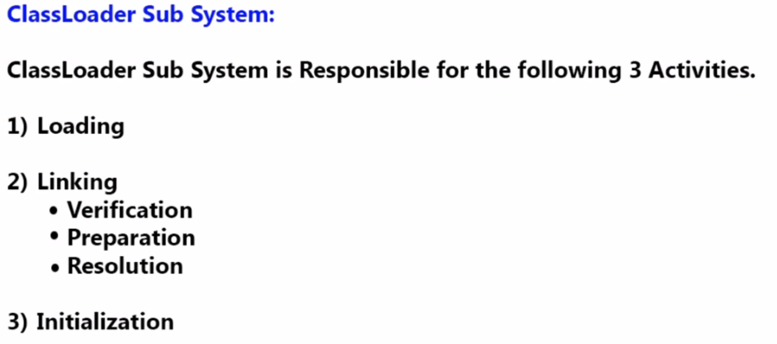

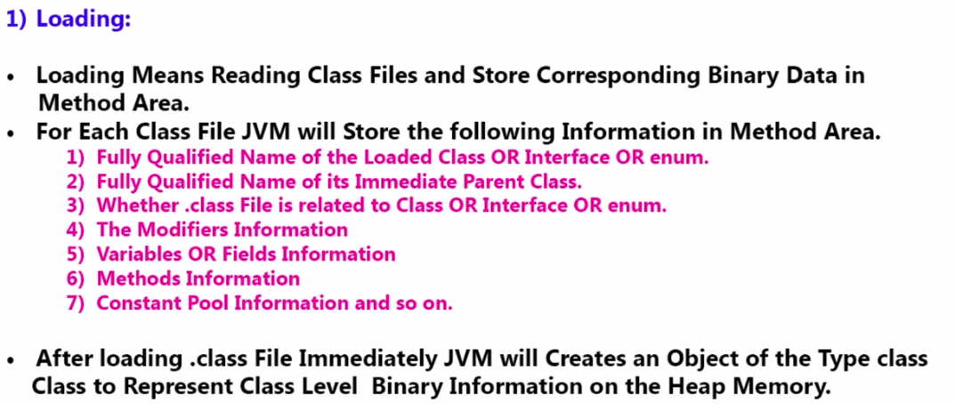

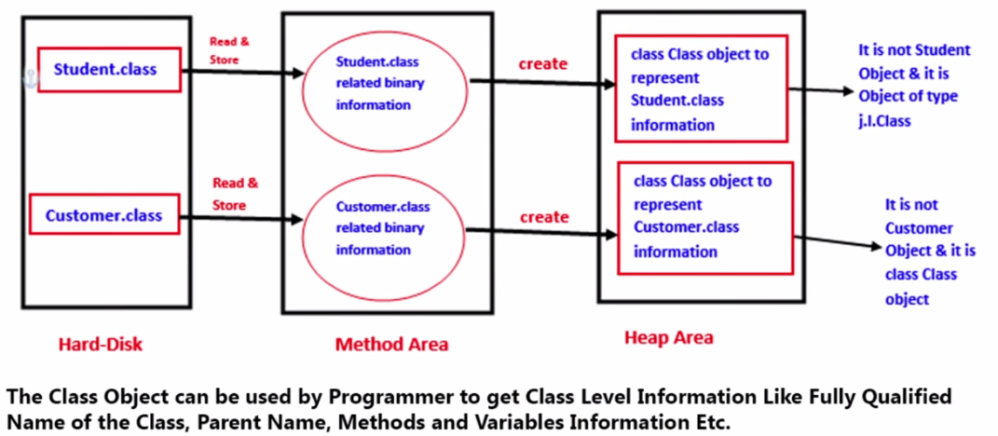

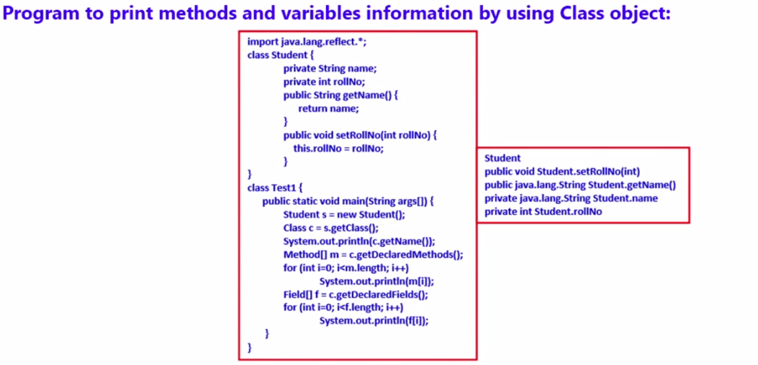

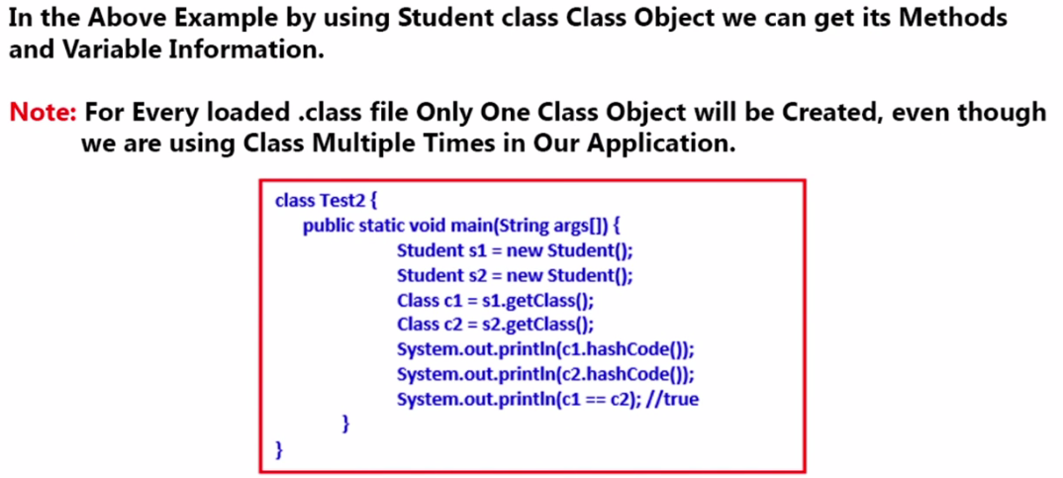

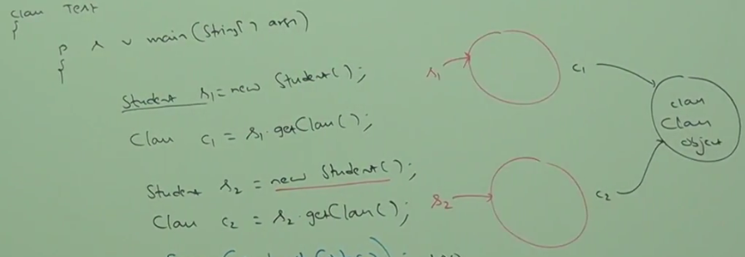

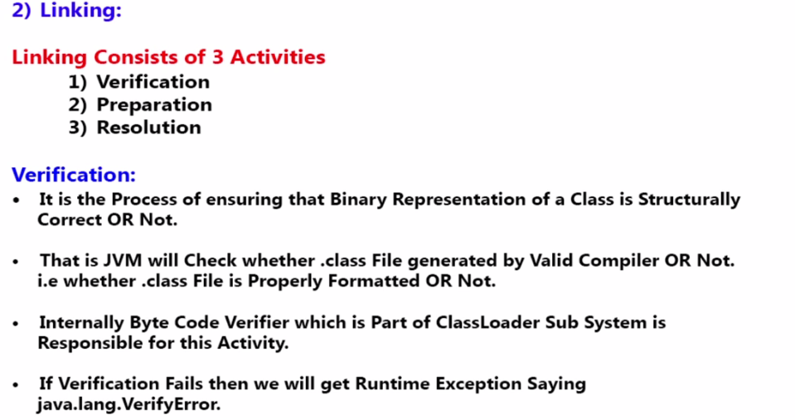

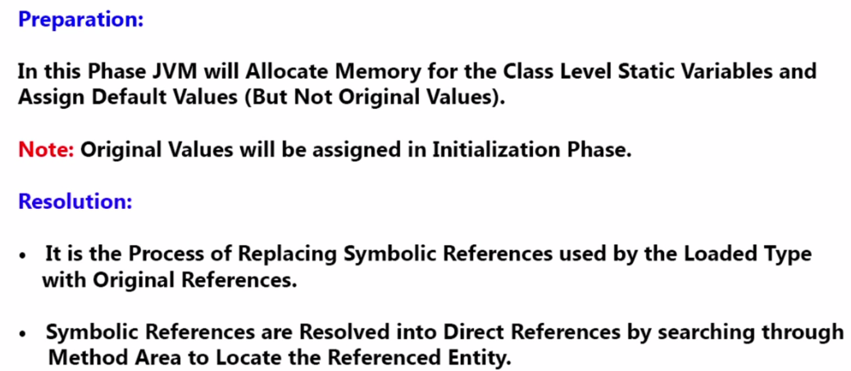

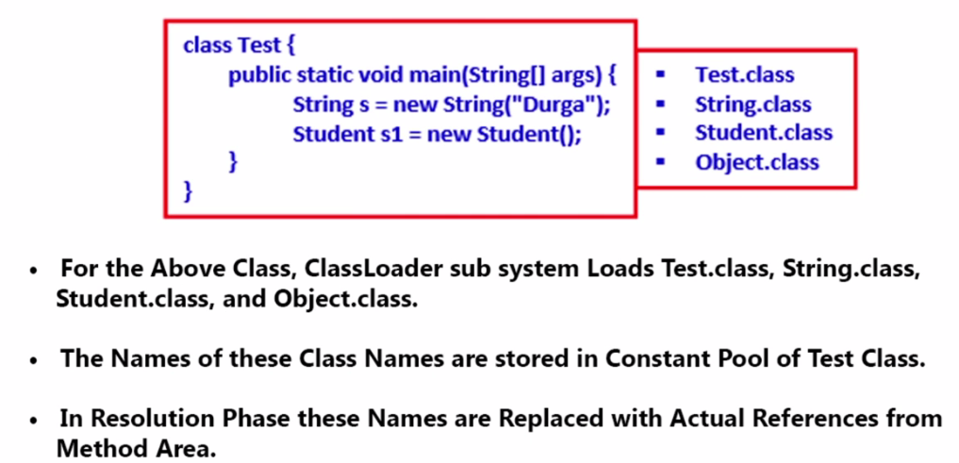

For every class JVM maintains a constant pool.

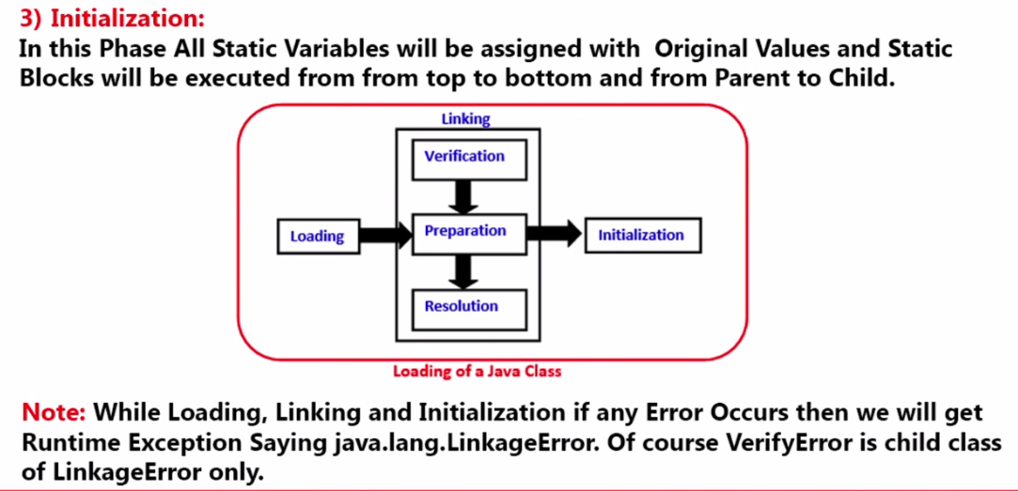

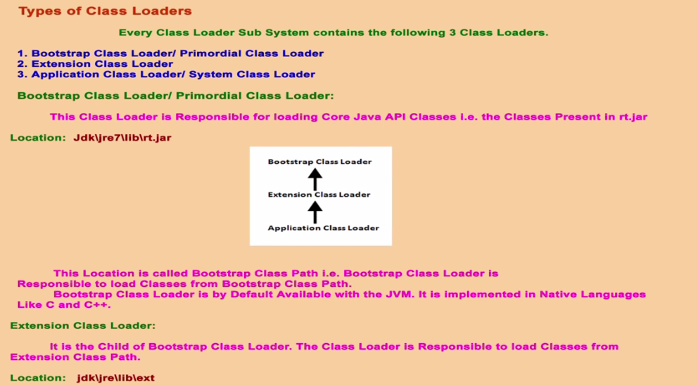

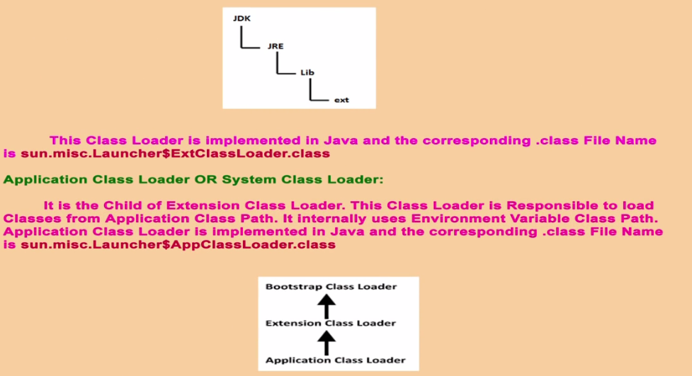

$--Inner Class. AppClassLoader is the inner class in Launcher Class

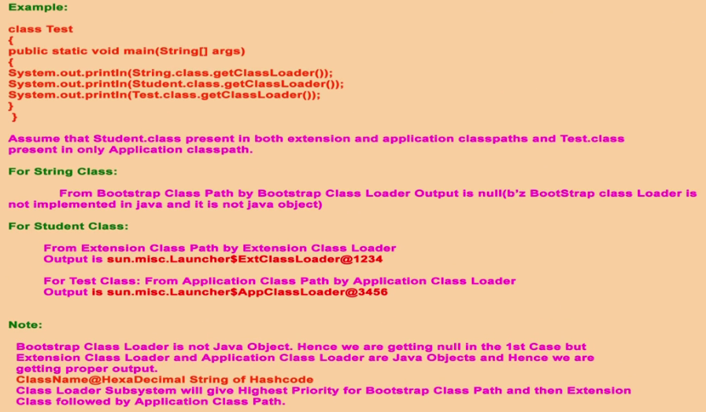

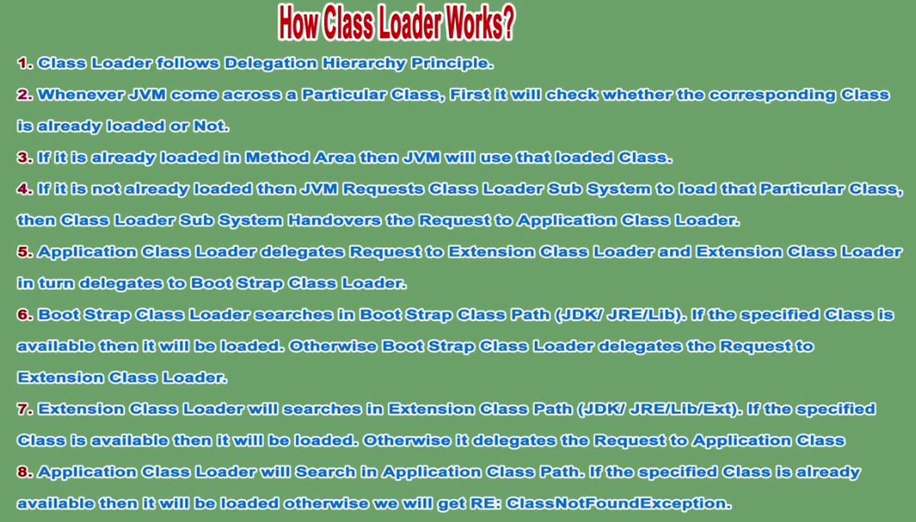

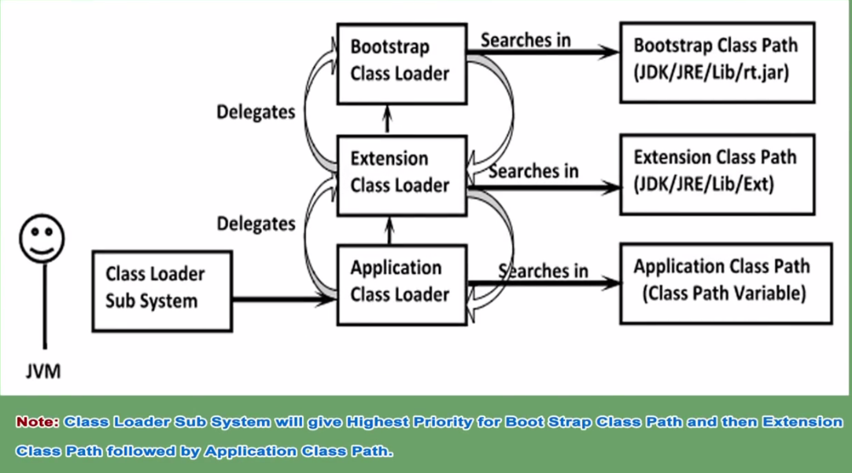

**Need of customized Class Loader:**

Default Class Loader will load .class file only once even though we are using multiple times that class in our program. After loading .class file if it is modified outside then default class loader won’t load updated version of class file. Because .class file already available in method area. We can resolve this problem by defining our own customized class loader. The main advantage of customized class loader is we can control class loading mechanism as per our requirement.

We can load .class file separately every time so that updated version available to our program.

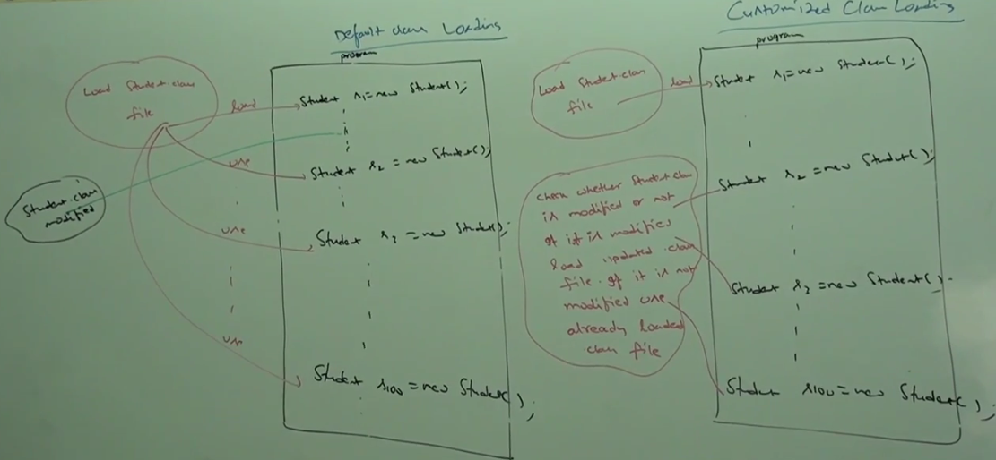

**How to define customized class loader:**

We can define our own customized class loader by extending java.lang,ClassLoader class.

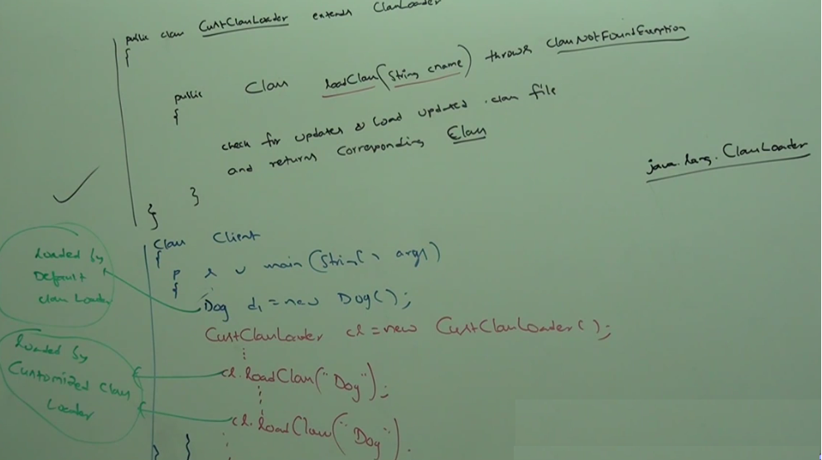

**Note*:** While developing webservers and application servers usually we can go for customized class loader to customize class loading mechanism.

Need or use of class loader Class: We can use java.lang.ClassLoader class to define our own customized class loader. Every ClassLoader in java should be child class of java.lang.ClassLoader class either directly or indirectly. Hence, this class access base class for all customized class loader.

**Various Memory Area Present Inside JVM:**

Whenever JVM loads and runs a java program it needs memory to store several things like bytecode, object, variables etc. Total JVM memory organized into following 5 categories:

1. Method Area
2. Heap Area
3. Stack Memory
4. PC Register
5. Native Method Stack

**Method Area:**

For every JVM one method area will be available. Method area will be created at the time of JVM start up. Inside method area class level binary data including static variables will be stored. Constant pools of class will be stored inside method area.

Method area can be accessed by multiple thread simultaneously.

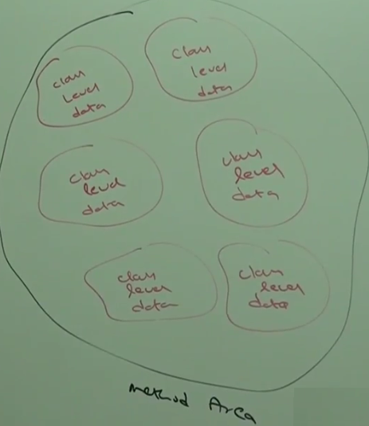

**Heap Area:** For every JVM one heap area is available. Heap area will be created at the time of JVM start up. Object and corresponding instance variables will be stored in the heap area. Every Array in java is object only. Hence arrays also will be stored in the heap area. Heap area can be accessed by multiple threads. Hence, data stored in heap memory is not thread safe. Heap area need not be continuous.

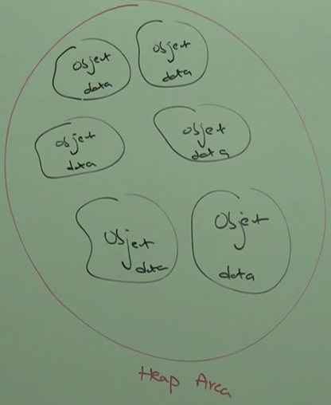

**Program to display Heap Memory Statistics:**

A java application can communicate with JVM by using run time object.

Runtime class present in java.lang package and it is a Singleton class. We can create runtime object as follows:

Runtime r = Runtime.getRunTime();

Once we got runtime object we can call the following methods on that object:

1. maxmemory()—It returns no of bytes of max memory allocated to heap.
2. totalMemory()—It returns no of bytes of total memory allocated to heap.
3. freememory()—It returns no of bytes of free memory present in the heap.

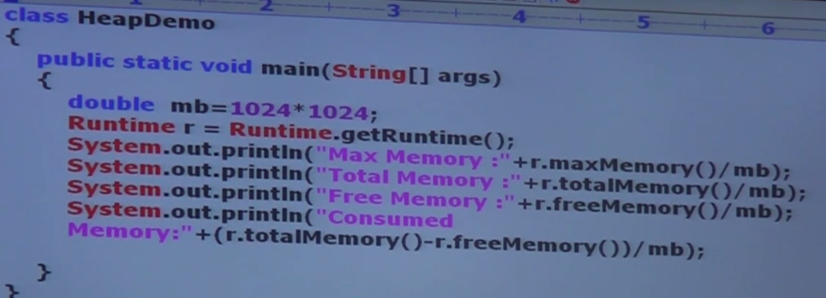

Heap memory is finite memory. But based on our requirement we can set maximum and minimum heap sizes i.e. we can increase or decrease the heap size based on our requirements.

We can use the following flags with java commands:

1. -Xmx: To set maximum heap size (Max memory).
2. -Xms: To set the minimum heap size (Min memory). We can use this command to set minimum heap size.

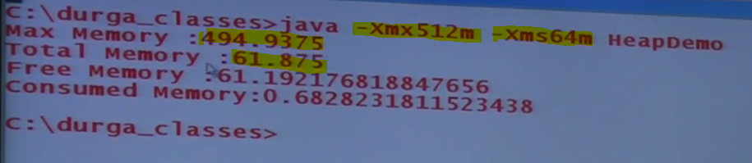

**Stack Memory:**

Method and Heap area-----Per JVM

For every thread JVM will create a separate Stack at the time of thread creation. Each method call performed by that thread will be stored in the stack including local variables also. After completing a method, the corresponding entry from the stack will be removed.

After completing all method calls the stack will become empty and that empty stack will be destroyed by JVM just before terminating the thread.

Each entry in the stack is called stack frame or activation record.

The data stored in the stack is available for the corresponding thread and not available to the remaining threads. Hence, these data are thread safe.

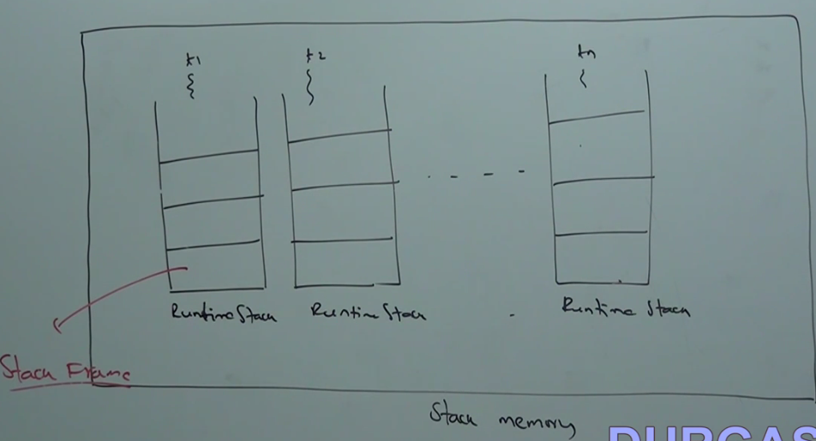

**Stack Frame Structure:**

Each stack frame contains 3 parts:

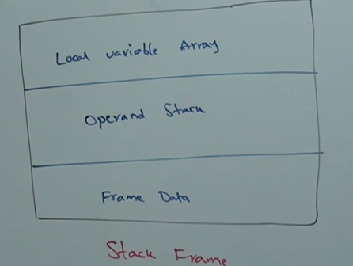

1. **Local Variable Array:**

It contains all parameters and local variables of the methods. Each slot in the array is of 4 bytes.

Values of type **Integer, float and reference occupy 1 entry** in the array. Values of **double and long occupy 2 consecutives entry** in the array. Byte, Short and Char values will be converted to Integer type before storing and occupying 1 slot. Way of storing Boolean values is varied from JVM to JVM.

Most of the JVM follows 1 slot for Boolean values.

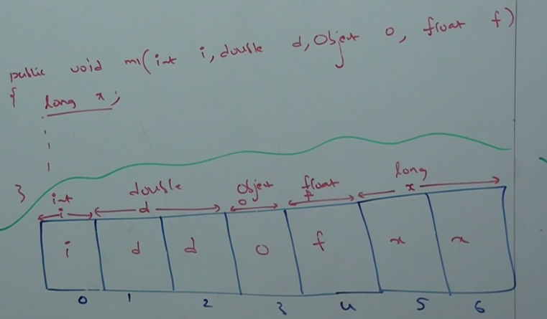

1. **Operand Stack:**

JVM uses operand stack as workspace. Some instructions can push the values to the operand stack and some instruction can pop values from operand stack. Some instruction can perform required operations.

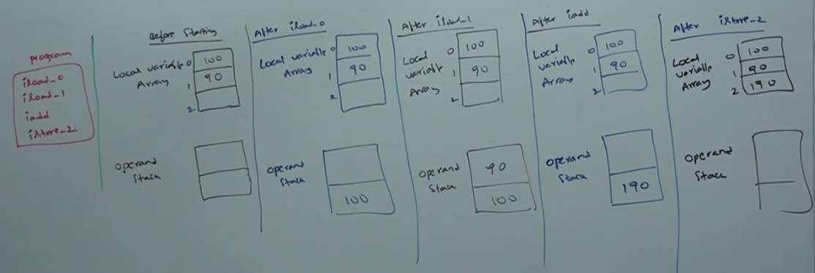

1. **Frame Data:**

Frame data contains all symbolic references related to that method. It also contains a reference to exception table which provides corresponding catch block information in the case of exceptions.

**PC Registers:**

For every thread a separate PC register will be created at the time of thread creation. PC registers contains the address of current executing instruction.

Once instruction execution completes automatically PC register will be incremented to hold address of next instruction.

**Native Method Stack:**

For every thread JVM will create a separate native method stack. All native method calls invoked by the thread will be stored in the corresponding native method stack.

Note:

1. Method area, Heap Area and Stack Area are considered as important memory areas with respect to programmer.
2. Method area and Heap area are per JVM. Whereas, Stack area, PC register and Native method stack are per thread.

Per Every JVM: One Heap Area, One Method Area

Per Every Thread: One Stack Area, One PC Register, One Native Method stack

Static variable🡪Class level🡪 Method area

Instance variable->Object level🡪Heap area

Local carriable 🡪Method level🡪 Stack area

**Very Important Concept:**

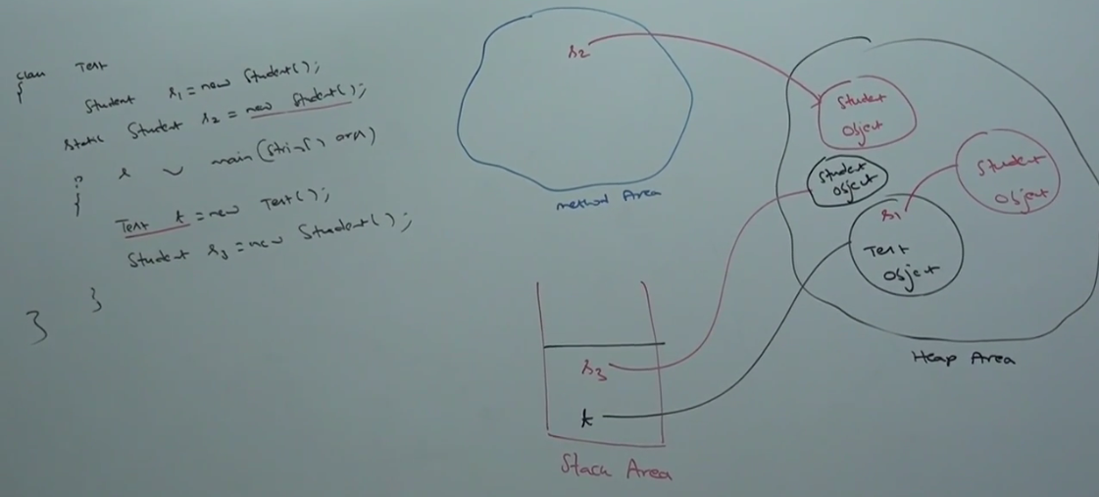

**Execution Engine:**

This is the central component of JVM. Execution engine is responsible to execute java class files. Execution engine mainly contains 2 components:

1. Interpreter
2. JIT compiler
3. **Interpreter:**

It is responsible to read byte code and interpret into machine code (Native code) and execute that machine code line by line. The problem with interpreter is it interprets every time even same method invoked multiple times which reduces performance of the system. To overcome this problem sun people introduced JIT compiler in 1.1 version.

1. **JIT Compiler:**

The main purpose of JIT compiler is to improve performance. Internally JIT compiler maintains a separate count for every method. Whenever JVM come across any method call first that method will be interpreted normally by the interpreter and JIT compiler increments the corresponding count variable.

This process will be continued for every method. Once if any method count reaches threshold value then, JIT compiler identifies that – the method is repeatedly used methods (Hot Spot). Immediately JIT compiler compiles that method and generates the corresponding native code.

Next time JVM come across that method call then, JVM uses native code directly and executes it instead of interpreting once again. So, performance of system will be improved.

The threshold count varies from JVM to JVM.

Some advanced JIT compiler will recompile generated native code if count reaches threshold value 2nd time. So, more optimized machine code will be generated.

Internally Profiler, which is the part of JIT compiler is responsible to identify Hot Spots.

**Note*:**

1. JVM interprets total program at least once. JIT compilation is applicable only for repeatedly required methods (Not for every methods).

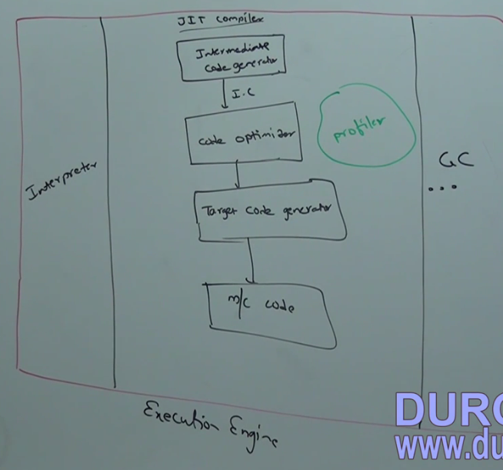

**Java Native Interface:**

JNI acts as mediator for java method calls and corresponding native libraries i.e. JNI is responsible to provide information about native libraries to the JVM.

Native method library provides or holds native libraries information.

**Magic Number:**

The first 4 byte of .class file is magic number. This is a predefined value used by JVM to identify, .class file is generated by valid compiler or not.

The value should be “0XCafeBabe”.

Whenever we are executing a java class if JVM is unable to find valid magic number then we will get runtime exception saying🡺 Java.lang.classFormatError (Incompatible magic value)

**Major & Minor Version:**

It represents .class file version. JVM will use these versions to identify which version of compiler has generated the current .class file.

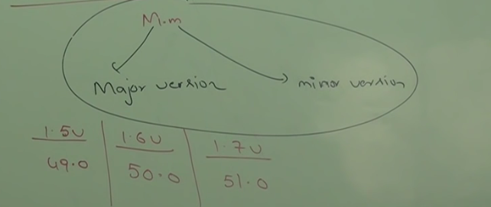

Lower version compiler generated .class files can be run by higher version JVM. But higher version compiler generated .class files can’t be run by lower version JVM.

We will get runtime exception🡪 UnSupportedClassVersionError

**Constant Pool:** It represents number of constants present in constant pool.

**Constant Pool Array:** It represents information about constant present in constant pool.

Access Flags: It provides information about modifiers declared to the class.

This_class: It represents fully qualified name of the class.

Super_class: It represents fully qualified name of immediate super class of current class.

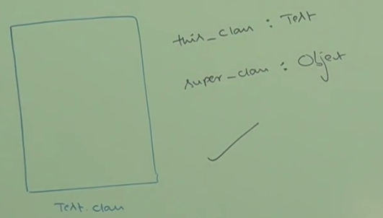

Interface_count: Number of interfaces implemented by current class.

Interface[] : It represents interfaces information implemented by current class

Fields[] –Fields information present in current class.

Methods_count: No of methods present in current class.

Methods []: It provides information about all methods present in current class

Attributes_count: No of attributes present in current class.

Attributes[] : Information about all attributes present in current class.

**Attribute🡪Instance variable**

**Fields🡪 Static variable**

**Javap -verbose Test.class 🡪 Information about Test class**

**Full JVM Architecture:**

